UNIT 1 RESEARCH ASSIGNMENT:

Extended Response



Overview: Energy and fuel value.
Combustion of organic material has been an integral part of homo-sapiens development and first used by cave-man as the burning of wood to both provide heat, and also cook food. The Industrial Revolution in the 1850s saw the first mass use of fossil fuels which had the heat energy to not only liberate the metals from their ore, but able to power the final products such as trains, ships and latterly cars. In today’s world with 7 billion people the demand for energy continues unabated. But with finite resources (oil at current production and consumption will last 50-60years) there has been huge investment into seeking bio-alternatives. Brazil, in 2007 mandated that petrol contain 25% ethanol, produced from the fermentation of sugar cane.

TASK:

Research the chemistry of fossil fuels and biofuels. Conduct your research under the following discussion points and present it as a 2 A4 page document which you can bring with you into the assessment :

Your document will be reduced to two pages if you make more. You may make it any size font you desire.

- Explain how fossil fuels and biofuels are formed, extracted, separated and ultimately used.

- Discuss the advantages and disadvantages of biofuels versus fossil fuels relating to their calculated fuel value, carbon imprint, sustainability and availability. (you need to have practiced calculations)

- Show an industrial process for the preparation of ONE common biofuel used in and around the home.

- There are various pollutants that are produced by the combustion of fossil and biofuels. Investigate the products/oxides of combustion of carbon, nitrogen and sulphur and summarise their impact on the environment and ways to reduce their pollution effects.

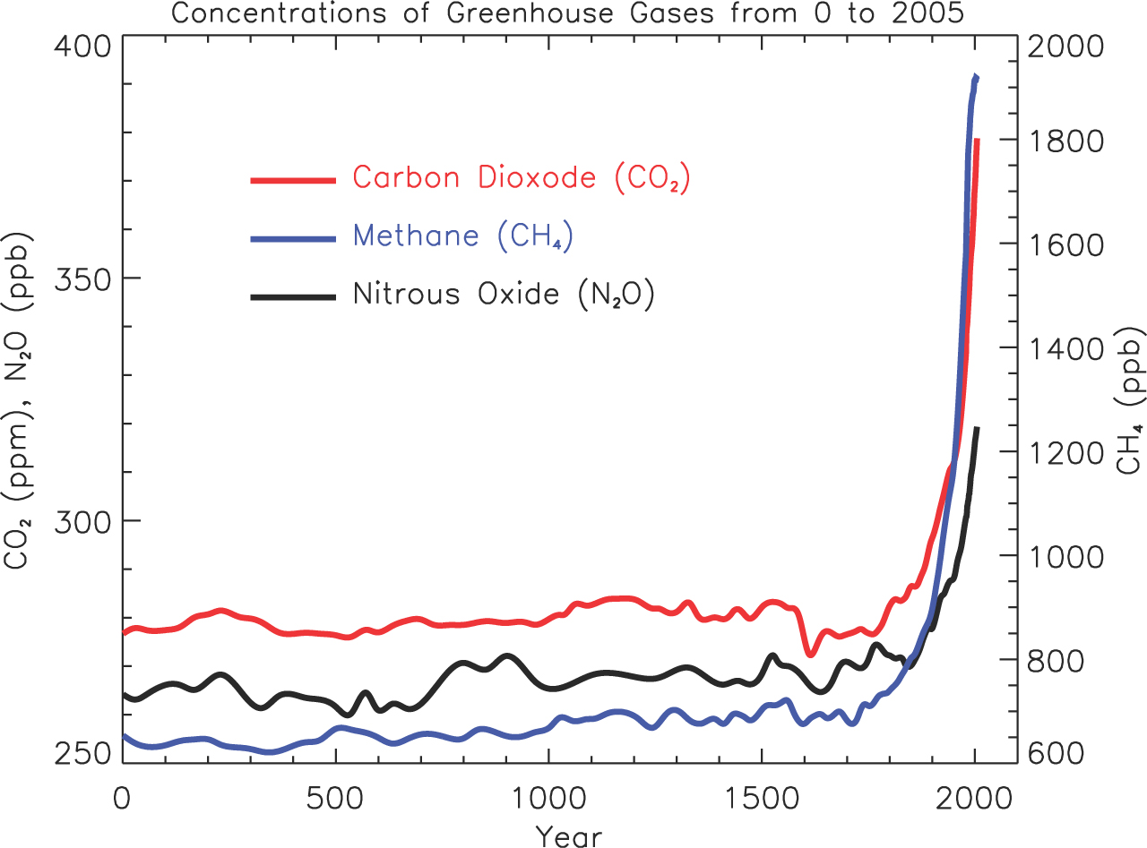

- You will be assessed on your written answers to Validation Test questions that will be completed in class.
- You will be able to use any text material that you have used in the compilation of the research assignment to assist in your answer.

How long will you need?
Two weeks to complete the task, you will then have 30 minutes to answer the validation questions on a confirmed date

What needs to be in your folio for assessment? | Due date
- Your 2 A4 pages of notes.  - Text books you use. | 27th April 2017

